Task-1
CODE:
include irvine32.inc
.data
myByte BYTE 20h
myWord WORD 1234h
myDword DWORD 12345678h

.code
main proc
;a
mov esi,offset myByte
mov al, [esi]
movzx eax,al
call writehex
call crlf

mov esi,offset myWord
mov ax, [esi]
movzx eax,ax
call writehex
call crlf

mov esi,offset myDword
mov eax, [esi]
call writehex
call crlf
mov eax,0
;b
mov ax, Word ptr [esi+2]
call writehex
call crlf
;c
mov bx,type myByte
movzx eax,bx
call writeDec
call crlf

mov bx,type myWord
movzx eax,bx
call writeDec
call crlf

mov bx,type myDword
movzx eax,bx
call writeDec
call crlf
exit
main endp
end main

OUTPUT:
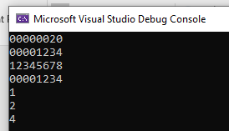

Task-2
CODE:
include irvine32.inc
.data
arr1 BYTE 60,70,80,90
arr2 WORD 500h,600h,700h
arr3 DWORD 6 DUP(0)
.code
main proc
;a
mov ax,lengthof arr1
movzx eax,ax
call writedec
call crlf

mov bx,lengthof arr2
movzx eax,bx
call writedec
call crlf

mov cx,lengthof arr3
movzx eax,cx
call writedec
call crlf
;b
mov ax,sizeof arr1
movzx eax,ax
call writedec
call crlf

mov bx,sizeof arr2
movzx eax,bx
call writedec
call crlf

mov cx,sizeof arr3
movzx eax,cx
call writedec
call crlf

exit
main endp
end main

OUTPUT:
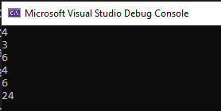
Task-3
CODE:
include irvine32.inc
.data
arrayB BYTE 15h, 25h, 35h
arrayW WORD 4444h,5555h,6666h
.code
main proc
mov esi,offset arrayB
mov al,[esi]
movzx eax,al
call writehex
call crlf
inc esi

mov al,[esi]
movzx eax,al
call writehex
call crlf
inc esi

mov al,[esi]
movzx eax,al
call crlf
call writehex
call crlf

mov esi,offset arrayW
mov ax,[esi]
movzx eax,ax
call writehex
call crlf
add esi,2

mov ax,[esi]
movzx eax,ax
call writehex
call crlf
add esi,2

mov ax,[esi]
movzx eax,ax
call writehex
call crlf
add esi,2
;c: increment is different because both arrays have different data type (Byte(1byte) and Word(2byte))
exit
main endp
end main

OUTPUT:
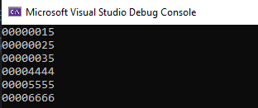
Task-4
CODE:
INCLUDE Irvine32.inc
.data
arrayD DWORD 2000h,4000h,6000h,8000h
.code
main PROC
;a
mov eax,arrayD[1*type arrayD]
call writehex
call crlf
;b
mov ebx,arrayD[3*type arrayD]
mov eax,ebx
call writehex
call crlf
;c Type returns/gives the size of data type in Bytes
exit
main ENDP
END main
OUTPUT:
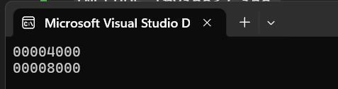
Task-5
CODE:
INCLUDE Irvine32.inc

.data
arrayB BYTE 15h,25h,35h
arrayW WORD 4444h,5555h,6666h
arrayD DWORD 2000h,4000h,6000h,8000h
.code
main PROC
mov esi,0
movzx eax,arrayB[esi]
call WriteHex
call crlf
inc esi
movzx eax,arrayB[esi]
call WriteHex
call crlf
inc esi
movzx eax,arrayB[esi]
call WriteHex
call crlf
mov esi,0
movzx eax,arrayW[esi]
call WriteHex
call crlf
add esi,type arrayW
movzx eax,arrayW[esi]
call WriteHex
call crlf
add esi, type arrayW
movzx eax,arrayW[esi]
call WriteHex
call crlf
mov eax, arrayD[1*type arrayD]
call WriteHex
call crlf
mov eax, arrayD[3*type arrayD]
call WriteHex
call crlf
exit
main ENDP
END main
OUTPUT:
